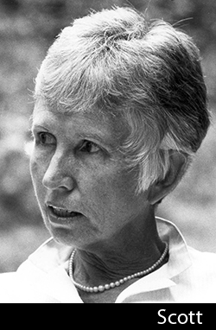
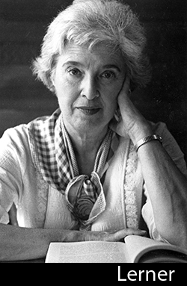
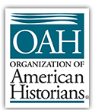
2019 Lerner-Scott Prize
DEADLINE: APPLICATIONS MUST BE SUBMITTED BY OCTOBER 1, 2018
The Lerner-Scott Prize is given annually by the Organization of American Historians for the best doctoral dissertation in U.S. women’s history. The prize is named for Gerda Lerner and Anne Firor Scott, both pioneers in women’s history and past presidents of the OAH.
A dissertation must be completed during the period July 1, 2017 through June 30, 2018 to be eligible for the 2019 Lerner-Scott Prize.
The prize will be presented at the 2019 OAH Annual Meeting in Philadelphia, Pennsylvania, April 4–6.

Application Procedures
Please send an electronic attachment (PDF) of your complete dissertation to the committee chair listed below by midnight (PST), October 1, 2018 with "2019 OAH Lerner-Scott Prize Entry" in the subject line. The committee chair must receive all applications by October 1, 2018.
Each application must also include a letter of support from a faculty member at the degree-granting institution, along with an abstract and table of contents. Faculty members should e-mail their letters separately to the committee chair, with "Recommendation for [applicant's name]" in the subject line. Please provide e-mail addresses for both the applicant and the adviser, if available.
Please also provide a cover letter describing the contribution of the dissertation to the field of U.S. women's history and any funding or project or travel grants that supported the completion of the dissertation.
The final decision will be made by the Lerner-Scott Prize Committee by February 2019. The winner will be provided with details regarding the OAH Annual Meeting and awards presentation. By applying for this prize, you are agreeing to OAH’s use of your data however it is needed in the normal course of business if selected as winner or honorable mention. Please see privacy policy at: ​http://www.oah.org/about/privacy/​.

Lerner-Scott Prize Committee
Sherry J. Katz, San Francisco State University (Committee Chair) - sjkatz@sfsu.edu
Leigh Fought, Le Moyne College
Natasha Zaretsky, Southern Illinois University
DEADLINE: APPLICATIONS MUST BE SUBMITTED BY OCTOBER 1, 2018

