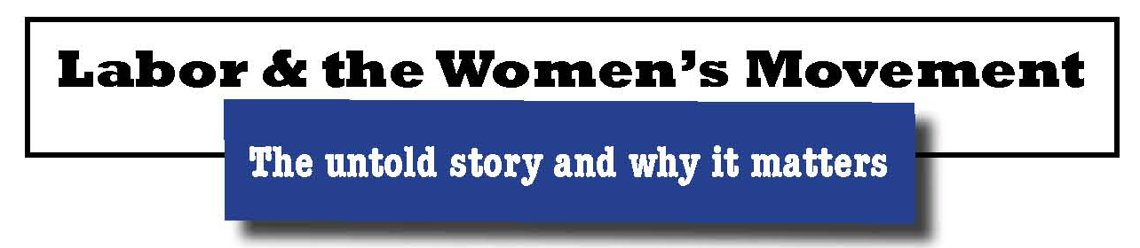

Event Explores Links Between
Labor and Women’s Movement

For immediate release Contact Kathy Rand
ksrand@icloud.com
312-543-2423

August 10, 2014 – The historical relationship between the labor movement and the women’s movement has been brought back into public view, thanks to the Supreme Court of the U.S. On June 30, the last day of its session, the Court issued rulings that are harmful to both women and labor unions. These rulings turn back previous advancements for both groups.

Many people are not aware of the role labor women played in the early history of the second wave women’s movement. With its recent decisions, the Supreme Court has reinforced why this untold story matters.

Veteran Feminists of America (VFA) will celebrate the contribution of labor women to the women’s movement at an event on Saturday, September 27, 2014, at the Renaissance Grand Hotel in St. Louis, Missouri.

“Labor & the Women’s Movement: The untold story and why it matters” will review the history, including what really happened to Rosie the Riveter. The keynote speaker will be Brigid O’Farrell, author of Rocking the Boat – Union Women’s Voices, 1915-1975 and She Was One of Us: Eleanor Roosevelt and the American Worker.

Several topics will be explored through panel discussions during the day:
- The personal stories of labor women who played key roles in founding the second wave women’s movement will be brought to life.
- Young feminist historians who are writing about the second wave will present their new scholarship.
- Success for women and labor through the legal system will be highlighted.
- A number of organizations grew out of the collaboration between labor and the women’s movement. Women playing key roles today in a number of those organizations will discuss their strategies for success.

The lunch speaker will be noted historian Dr. Alice Kessler-Harris, the R. Gordon Hoxie Professor of American History at Columbia University. She has written extensively on women’s labor history.

The closing session will look to the future and stress the importance of women and labor working together to preserve the victories that have been gained. Closing speakers will be Dr. Emily E. LaBarbera Twarog, Assistant Professor, University of Illinois School of Labor & Employment Relations, and Mary Anne Sedey, St. Louis employment attorney.

Saturday night will feature an awards dinner, honoring feminists and labor leaders.

VFA is a national non-profit organization for those who pioneered the second wave of the feminist movement in the 1960s and ‘70s. Its goals are to document the history of the movement; to rekindle the spark and spirit of the feminist revolution; and to ensure that the ideals of feminism continue to reverberate and influence others, including younger generations.

More details on the agenda and speakers as well as a registration form are available on the event website, http://www.vfa-midwest.org.

###

